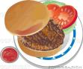

Lincoln, MA 01773 http://www.lincolnscouts.org

PLEASE NOTE:

Veggie Burger’s are available $3.00
(ask for cheese if you want it)

Chips are Potato or Doritos $1.00

