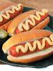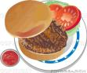

Lincoln, MA 01773 http://www.lincolnscouts.org

Scout Café Menu
11:30 – 1:00 Pierce House

Hamburger/Cheeseburger $3.00

Hot Dog $2.00

Chips $1.00

Soda/Water/Lemonade $1.00

